**Switches and its Types**

There are two types of switches namely:

1. Mechanical switches
2. Electronic switches

**Mechanical switches** must be activated physically, by moving, pressing, releasing, or touching its contacts.

**Electronic switches** do not require any physical contact in order to control a circuit. These are activated by semiconductor action.

**Types of mechanical Switches:**

1. Single Pole Single Throw Switch (SPST)

It switches a single circuit and it can either make (ON) or break (OFF) the load.

The contacts of SPST can be either normally open or normally closed configurations.

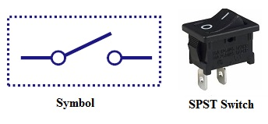

1. Single Pole Double Throw Switch (SPDT)

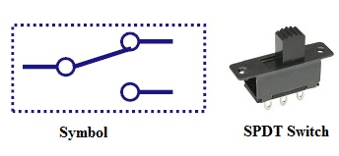

This switch has three terminals, one is input contact and remaining two are output contacts.

This means it consist two ON positions and one-OFF position.

In most of the circuits, these switches are used as. changeover to connect the input between two choices of outputs.

1. Double Pole Single Throw Switch (DPST)

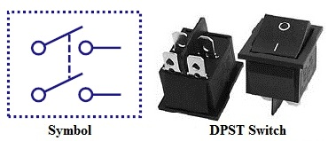

This switch consists of four terminals,two input contacts and two output contacts.

It behaves like a two separate SPST configurations, operating at the same time.

It has only one ON position, but it can actuate the two contacts simultaneously, such that each input contact will be connected to its corresponding output contact.

In OFF position both switches are at open state.

This type of switches is used for controlling two different circuits at a time.

1. Double Pole Double Throw Switch (DPDT)

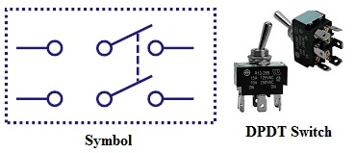

This is a dual ON/OFF switch consisting of two ON positions.

It has six terminals,two are input contacts and remaining four are the output contacts.

It behaves like a two separate SPDT configuration, operating at the same time.

Two input contacts are connected to the one set of output contacts in one position and in another position, input contacts are connected to the other set of output contacts.

Is used to vary the direction of rotating motors.

1. Push Button Switch

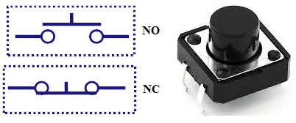

It is a momentary contact switch that makes or breaks connection as long as pressure is applied (or when the button is pushed).

1. Limit Switch

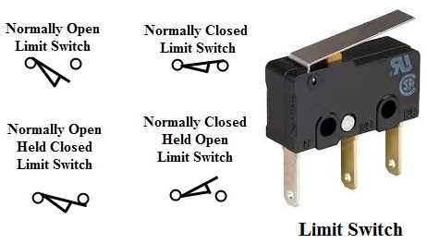

Some switches are operated by the presence of an object or by the absence of objects or by the motion of machine instead of human hand operation. These switches are called as limit switches.

These switches consist of a bumper type of arm actuated by an object. When this bumper arm is actuated, it causes the switch contacts to change position.

1. Float Switches

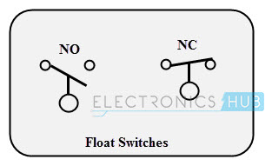

Float switches are mainly used for controlling DC and AC motor pumps according to the liquid or water in a tank or sump.

This switch is operated when the float (or floating object) moves downward or upward based on water level in a tank.

**CONNECTORS**

**Connector Terminology**

**Gender** - The gender of a connector refers to whether it plugs in or is plugged into and is typically male or female

**Polarity** - Most connectors can only be connected in one orientation. This trait is called polarity, and connectors which have some means to prevent them being connected wrong are said to be polarized, or sometimes keyed.

**USB Connectors**

**USB connectors come in two flavors**: host and peripheral. In the USB standard, there is a difference between the two, and the connectors on cables and devices reflect this.

**USB-A Connectors**

USB-A female is the standard “host” connector type. This is found on computers, hubs, or any device intended to have peripherals plugged into it. It is also possible to find extension cables with a female A connector and a male A connector on the other end.

USB-A male is the standard “peripheral” connector type. Most USB cables will have one end terminating in a USB-A male connector, and many devices (such as keyboards and mice) will have a built-in cable terminated with a USB-A male connector. It’s also possible to find USB-A male connectors that are board mountable, for devices like USB memory sticks.

USB-B Connectors

USB-B female is a standard for peripheral devices. It’s bulky, but robust, so in applications where size is not an issue, it’s the preferred means for providing a removable connector for USB connectivity. It is usually a through-hole board mount connector, for maximum reliability, but there are panel-mount options for it as well.

USB-B connector on an Arduino Uno

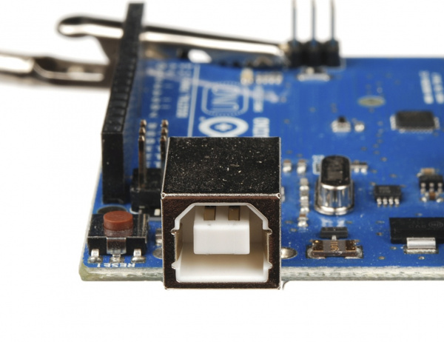

USB-B male is almost exclusively found at the end of a cable. USB-B cables are ubiquitous and inexpensive, which also contributes to the popularity of the USB-B connection.

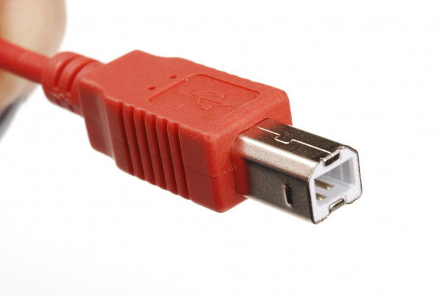

USB-Mini Connectors

The USB-Mini connection was the first standard attempt to reduce the size of the USB connector for smaller devices. USB-Mini female is typically found on smaller peripherals (MP3 players, older cellphones, small external hard drives), and is usually a surface mount connector, trading robustness for size. USB-Mini is slowly being phased out in favor of the USB-Micro connector.

